I’ve prepared a simulation of a room with TABS (in the ceiling). I have a problem with temperatures that I get in this ceiling. I wonder if it is due to the boundary conditions settings.
Please take a look at the graphical representation of the situation below:
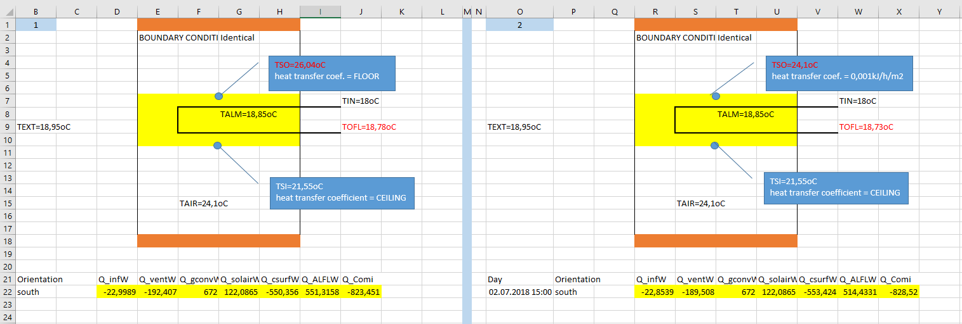

- Do I understand correctly that “heat transfer coefficient” (Manual TRNSYS17, Volume 5 page 109) is supposed to be set to “less than 0,001kJ/h/m²” regardless of conditions being adiabatic or not?
- As far as remaining partitions are concerned, should I set “heat transfer coefficient” to “less than 0,001kJ/h/m²”?
- My room has surface area of 48m² and volume of 129m³. TABS settings: m_water=601.2kg/h, T_Water=18°C. TOFL-TIFL =0.7K
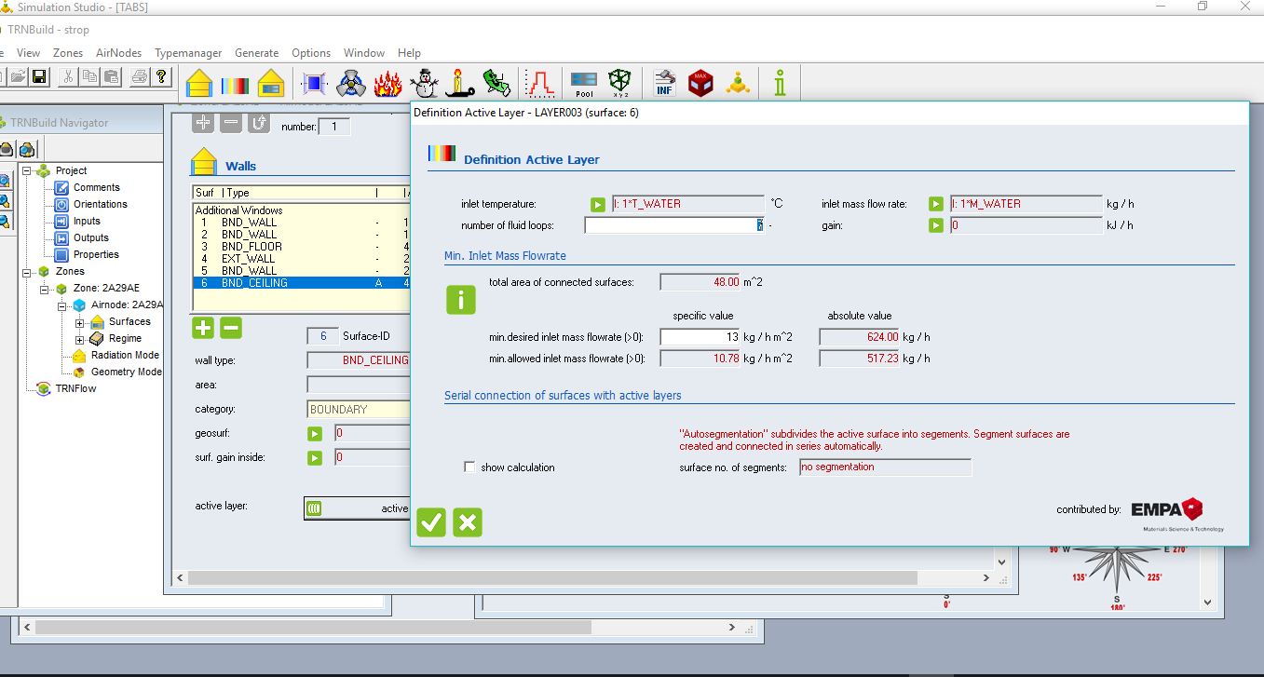

What else can cause water temperature difference to be so low?

