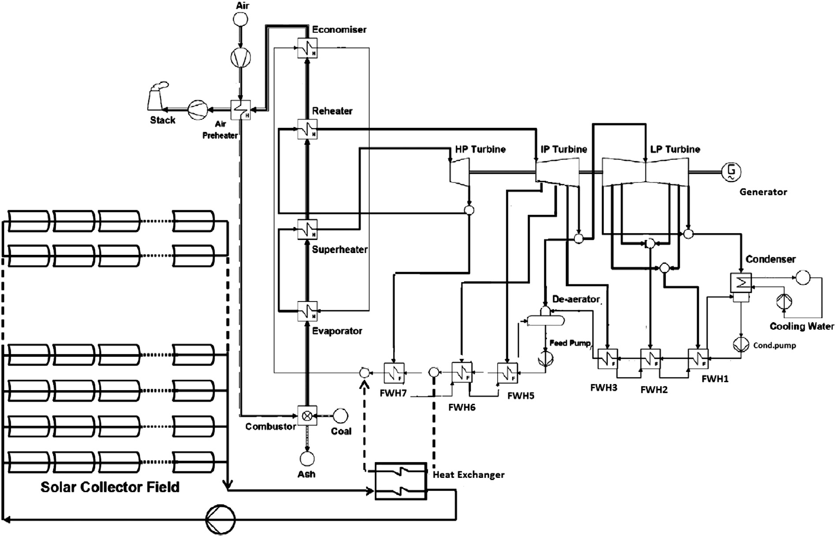

Fig. 1. Schematic representation of 300 MW power plant with SAPG.

Please see the feedwater heater parts: FWH3 and FWH2; below is other user’s model.

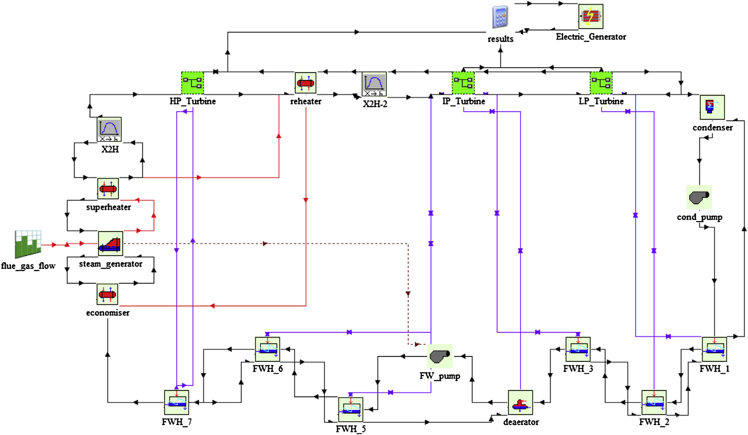

Fig2 Rankine cycle model.

Take FWH2 as an example, it is connected with 5 arrows the purple one on the top represent the extraction steam; the middle two represent the feedwater get into and out of the FWH2 and the bottom two represent cold steam from FWH3 and cold steam to FWH1.

In my case, however, I can not find out where to connect all five arrows, only four parts are available.

You see, there are two blue arrows. What should I do? Thank you

