Attempt to model an apartment buliding, with no cooling. Boiler-fed baseboad heat in each apartment. 100% outdoor air supplied to all corridors 24/7/365 which is how the suites receive fresh air ventilatlion. Enough fresh air is supplied to the cooridors such that the pressure is higher in the corridors than the suties, allowing the air to pass around the edges of each suite door into the suites.

There are seven questions in this word document, easily found by doing a control-F command in Microsoft Word and search for the word **Question**

Setting up the building, leaving most options as default for a multifamily high-rise:

**Question:** I’m not sure if choosing “HW Baseboards (only) with NO zone ventilation” is correct:

Envelope:

**Question**: what impact does this building operation schedule have?

**Question**: what impact does this HW Plant Equipment operation schedule have?

In detailed mode, it is showing the system as “Unit Heater”, heat source = “none” (instead the heat is from the baseboards). It won’t let met pick an outdoor air setup, so I subsequently had to which from “Unit Heater” to “Unit Ventilator” (as you’ll see about half way down this word document)

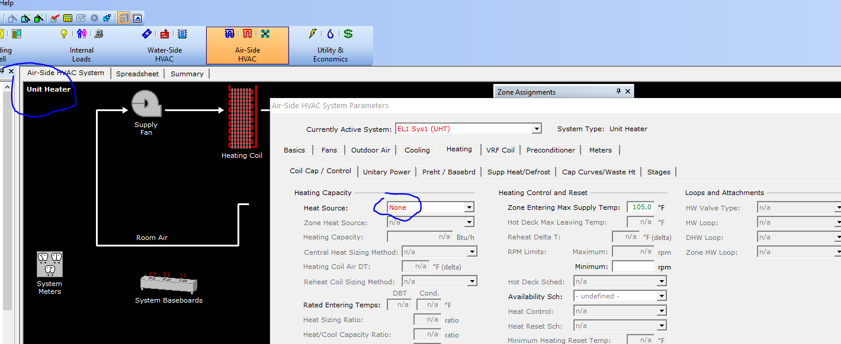

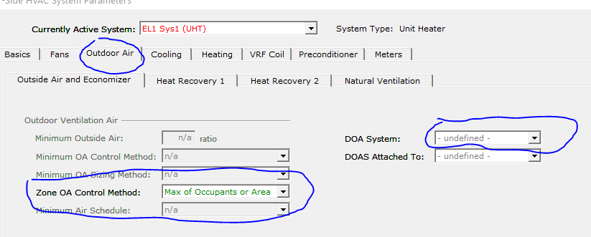

Create the DOAS system:

DOAS system:

Running a test simulation before attaching DOAS to the heating system: Note that there is no Ventilation Fans energy yet, will need to ensure the final model does have ventilation fan energy.

Attach DOAS to the “Unit Heater” system:

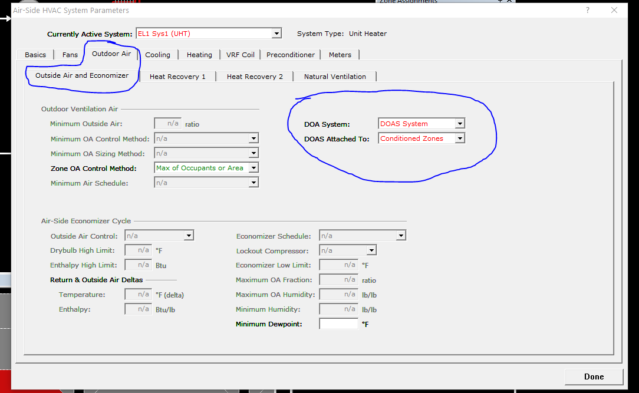

Run a simulation to see what changed:

Hourly report looks like this for one of the zones, January 2 is shown below:

Looks good, if zone temp is above about 69F, the baseboards output becomes 0 btu/h.

**Question:** Is there a way to show how much outdoor air is entering the zone in Hourly Reports?

Try to set DOAS to run 24/7/365 (I’m not sure what schedule it is running on as default):

Before my attempt:

It won’t let me change Minimum Outside Air.

Switch from Unit Heater to Unit Ventilator:

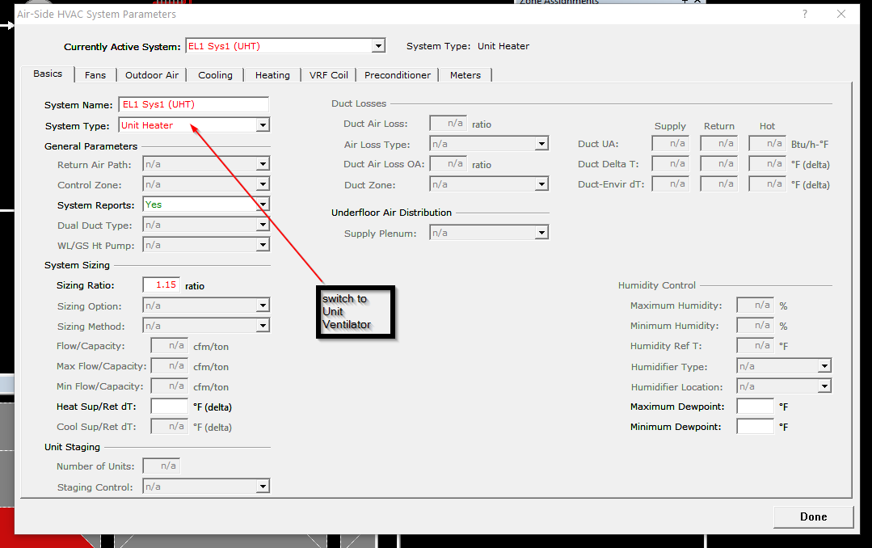

Now the boxes look different here:

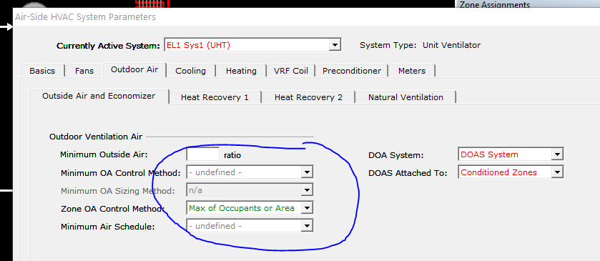

Choose these options, I believe 1.00 means that 100% of the air entering zone is outside air:

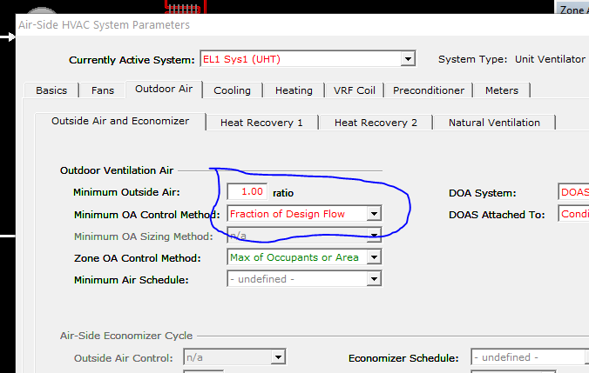

“Fraction of Design Flow” means “DOAS-supplied airflow is constant all hours that DOAS is operating”



Re-run simulation: Value are identical to previous simulation.

Could this be the problem? OA Flow/Person is blank here:

Change to this, using an Input Expression 5*#LR("SPACE","NUMBER-OF-PEOPLE")+.06*#LR("SPACE","AREA")

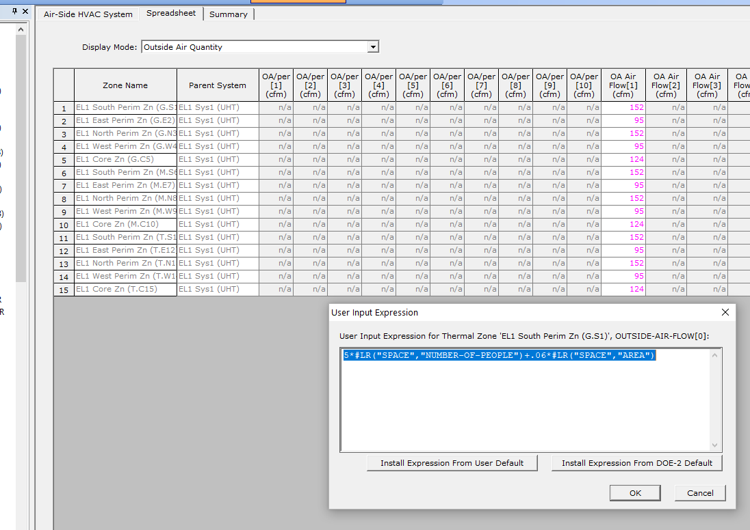

Re-run simulation:

I now have ventilation fan electricity use. Compared to the previous simulation, Space heating increased from 517 MBtu to 1420 MBtu.

This is what the hourly results looks like now for January 2nd:

I don’t want the air flow to go off from 8am-6pm. I’m not sure where this setting is coming from but it might be this “Cooling” Fan Schedule, although it says it is for cooling (the building has no cooling):

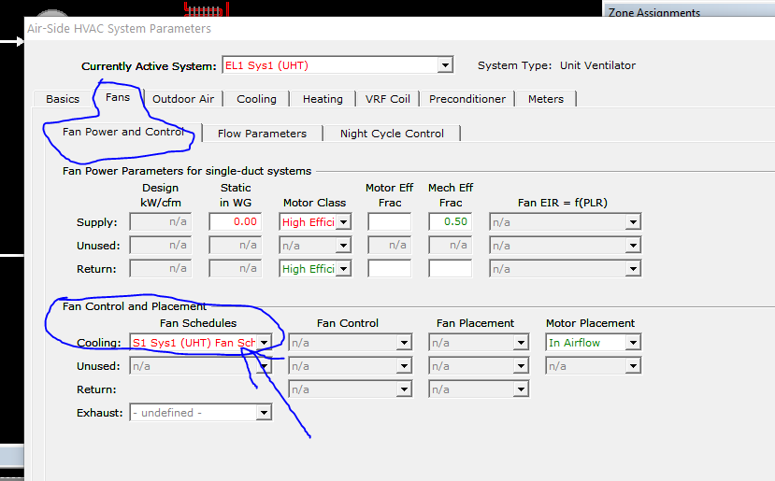

This is the S1 Sys1 (UHT) Fan Sch:

Sure enough, it is set to “0” from 7am to 6pm.

Switch to “1’s” 24/7.

Re-run simulation. New simulation and hourly report shown below:

Space heat gas consumption increased from 1419 MBtu to 1776 Mbtu. But when I look at the Hourly Reports, I’m not getting air flow 24/7 on January 2nd. On Jan 1st, a holiday, it is 0 – need to fix the holiday cooling fan schedule.

Need to change the Fan WEH to be “1” 24/7 as well:

What about exhaust?

I’ve heard that for apartment buildings, they want to have positive pressure because the fresh air is normally provided into the hallways, and enters the suites around the edges of the door. There is no supply air duct inside each suite, which is the case for many apartments I’ve been to. (Perhaps newer apartment buildings, or others that I’ve not seen, do have supply air ducts inside the suites.)

For simplicity I’m going to say that the exhaust air is simply 25% less than the outside air supply, but using this user expression (note the 0.75 I added):

0.75*(5*#LR("SPACE","NUMBER-OF-PEOPLE")+.06*#LR("SPACE","AREA"))

New simulation results. **Question**: Why did fan electricity consumption decrease after I added exhaust? Ventilation fan electricity is now lower (which seems odd since I added exhaust?). Space heat gas use increased – I’m not sure if this makes sense since the outdoor air supply is the same. I suppose adding exhaust will increase infiltration, causing increased heating demand?

New hourly results, Exhaust Air is showing up:

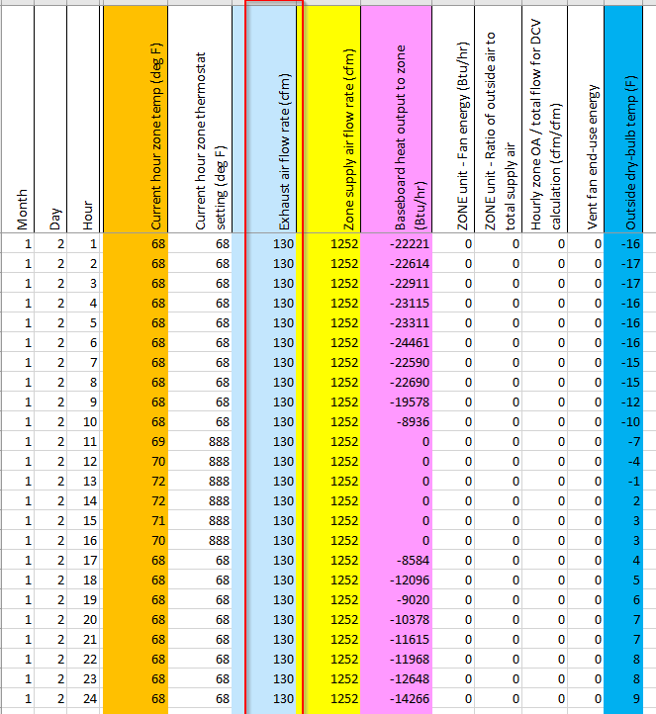

Set ERV Fans to “Self Contained” to avoid a simulation error:

New results below. Massive reduction in space heat gas, dropped from 1882 MBtu to 1023 MBtu. **Question:** Is this realistic? Fan electricity use increased from 32,000 kWh to 58,000 kWh, I assume due to the ERV fans.

Overall, the building model shows consumption of 1742 GJ gas and 1062 GJ electricity, totaling 2803 GJ/year (779,000 kwh/year). The building total area is 27,000 ft2 (2509 m2). This is an EUI of 28.8 kwh/ft2. Or, 1.12 GJ/m2 in metric.

I’m sure there are some errors as I’m by no means an expert in this DOAS setup.

I find this to be a useful summary:

