Modeling View Dynamic Glass in eQUEST
This document provides a step-by-step method to model View Dynamic Glass in eQUEST building energy simulation software. This type of glass is referred to as “switchable glazing” in eQUEST component terminology.

Prerequisite
Up to eQUEST version 3.65, the software has functionality to model switching between two tint states only. For the simulation to work, it is required that the glass definitions for the tint states be stored in the eQ_Lib.dat file found in the following folder (location may vary on computers with custom eQUEST installation):
C:\Users\<enter current username>\Documents\eQUEST 3-64 Data\DOE-2

Modeling steps
- In the above-mentioned folder, create a copy of the existing eQ_Lib.dat file, to serve as backup if needed later. Replace the original eQ_Lib.dat file with the eQ_Lib.dat provided by View Dynamic Glass (VDG). The provided file contains the glass type definitions for VDG in its clear and darkest tint states. To request a copy of VDG’s custom library file, please contact us; details on the last page.
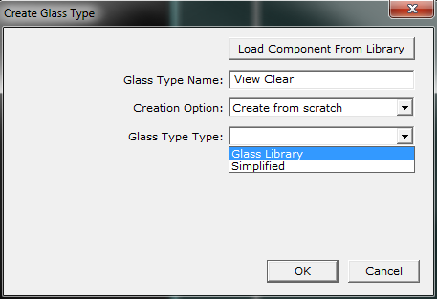
- In eQUEST, create a new glass type to represent VDG clear state. Name it “View Clear”. Select “Glass Library” under “Glass Type Type”.

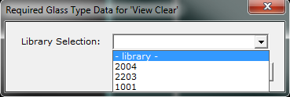
- In the next window, select “- library -“.

- In the next window, select “Double Electro” from the first box, and “2878” from the second box.
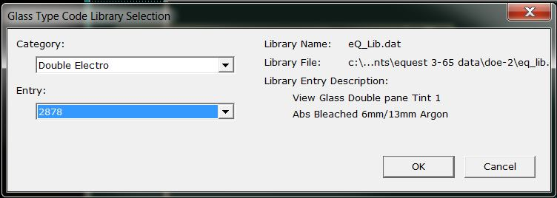

- Repeat steps 2-5, to create another glass type to represent VDG darkest tint state. Use “View Tint” as the “Glass Type Name” and select “2879” from the second box in step 4.
- Assign “View Clear” as the glass type for all relevant windows. To assign “View Clear” to all windows, use the window spreadsheet mode in eQUEST. Set “View Clear” as the default glass type and assign to all windows. Assign “Specification Method” as “Composite” default to all windows.

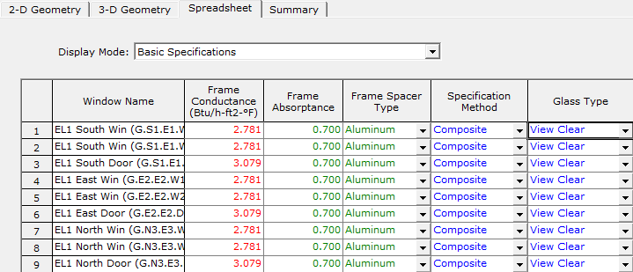

- Set up switchable glazing parameters. In the window spreadsheet mode, for each window that has “View Clear” assigned as its “Glass Type”, assign “View Tint” as the “Glass Type Sw”, enter 25 as the value in both “Switch Set Lo” and “Switch Set Hi”.
- For each window with “View Clear” as the “Glass Type”, note whether the parent space has DAYLIGHTING set to “Yes” or “No”.
  - For spaces with DAYLIGHTING = “Yes”, and window glass type “View Clear”, set the “Switch Control” to “Daylight Level”.
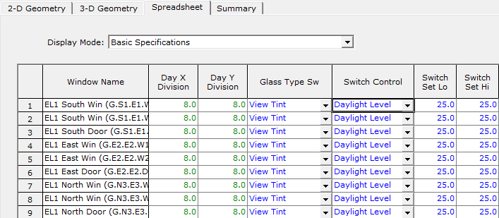

  - For spaces with DAYLIGHTING = “No”, and window glass type “View Clear”, set “Switch Schedule” as default “Hourly Report Schedule”, or another schedule as appropriate.
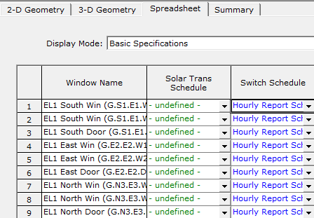

  - For spaces with DAYLIGHTING = “No”, and window glass type “View Clear”, set the “Switch Control” to “Tot Sol Inc”. Note that there is a typo in eQUEST dropdown list for “Switch Control”. Hence, select the first instance of “Tot Sol Tr”, which is in fact “Tot Sol Inc”.
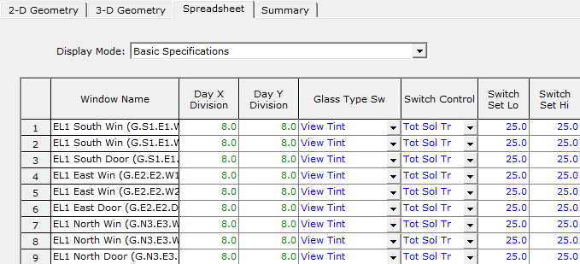

- VDG assignment is complete. You may run the simulation at this time. Note that the method described in this document has been validated in eQUEST versions 3.63, 3.64 and 3.65. If you are using a later-released version and encounter errors or bugs, please contact us for support.

Have questions?
For more information and guidance on modelling View Dynamic Glass in eQUEST,
please contact us at:

Email: simulation@viewglass.com
Phone: 1-408-263-9200

