BUILDING SIMULATION USERS’ GROUP (BSUG)
Energy Modeling – Making Informed Design Decisions with Building Energy Models
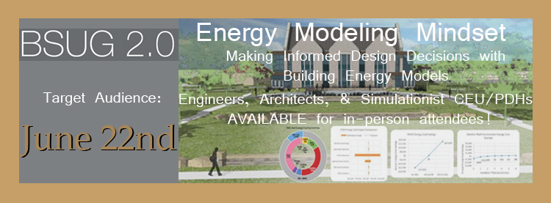
Target Audience: | Engineers, Architects, & Simulationists –  CEU/PDHs AVAILABLE for in-person attendees!
Date and Time: | June 22, 2016 – 12:00 to 1:00 p.m. MT
Location: | UI - IDL Classroom – 306 S 6th St. Boise, ID
Registration: | Remote Webinar or Live Presentation*  *FREE LUNCH provided to in-person attendees registered 24 hours in advance

Description:
Once considered a costly exercise reserved only for high performance or “green” buildings, energy models are now becoming standard practice. Timely building performance models can reduce construction costs, operational costs, and lessen a project’s environmental impact. This session will provide a guide to navigating the treacherous “rapids” of building energy modeling for design optimization.
Learning Objectives:
- Understand proper usage of energy modeling techniques at each project phase
- Apply Software technologies to provide timely data to assist in the selection of building systems
- Understand how to best support Architects and Engineers in making informed decisions
- Prepare for future standards and regulations
Bio:
Working out of the Energy Services group at CTA Architects Engineers’ downtown Boise office, Tim Johnson is a veteran professional mechanical engineer and ASHRAE building energy modeling professional. He specializes in building performance analysis and has provided design and energy services for more than 100 projects – including Pahranagat National Wildlife Refuge, a zero net energy (ZNE) facility in southern Nevada, and several joint efforts with the National Renewable Energy Lab (NREL).

